**

4/10/2020

*LAB#07*

*Lab Title: While Loops in C Programming*

*Date:*

*SECTION: A*

*SUBMITTED TO: Engr Sadia Jabeen*

*SUBMITTED BY: Muhammad Mustafa*

*SUBJECT: Programming Fundamental*

*DEPARTMENT: Electrical Engineering*

*Semester: 2nd*

*Reg.No: 19MDELD045*

*BATCH: 2nd*

*Task no 1:*

* Write a C program to enter all numbers entered by a user until user enters 0.

1. * Algorithm***:**
2. In the first step we have to start the program and after that we have to declare two integer and initialize one of the above two integer.
3. In the next step we have the start the do condition and read the above integer inside the loop.
4. And put the condition and after that we have to add the while condition.
5. And simply end the program.

*Flow Chart:Task01*



START



int sum = 0

int num



READ

num



num

≠

?

0



STOP



Sum+= num



WRITE

"sum"

*YES*

*NO*

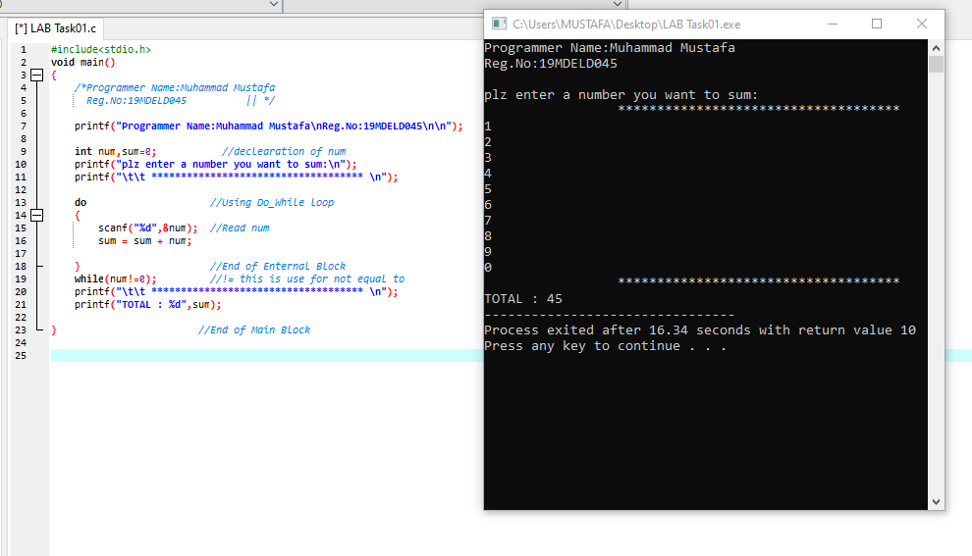

*Task no 2:*

 **Write a program to find the HCF and LCM of two numbers.**

 **HCF:**

* In [mathematics,](http://en.wikipedia.org/wiki/Mathematics) the greatest common divisor (gcd), also known as the greatest common factor (gcf), or highest common factor (hcf), of two or more [integers](http://en.wikipedia.org/wiki/Integer) (at least one of which is not zero), is the largest positive integer that [divides](http://en.wikipedia.org/wiki/Divisor) the numbers without a [remainder.](http://en.wikipedia.org/wiki/Remainder) For example, the GCD of 8 and 12 is 4.

 **LCM:**

* In [arithmetic](http://en.wikipedia.org/wiki/Arithmetic) and [number theory,](http://en.wikipedia.org/wiki/Number_theory) the least common multiple (also called the lowest common multiple or smallest common multiple) of two [integers](http://en.wikipedia.org/wiki/Integer) *a* and *b*, usually denoted by LCM(*a*, *b*), is the smallest positive integer that is [divisible](http://en.wikipedia.org/wiki/Divisible) by both *a* and *b*

 *Algorithm of Task02:*

1. In this program we have to determine the LCM and HCF ao any two number.
2. First we have to declare the two numbers and after that initialize these number to two new number for the purpose that these two numbers changes into another two number during the process of finding HCF of the number that’s why.
3. Put the do condition and after that we have to start the loop and put the different condition and after that put the while and after that the HCF will be calculated and after that we have to make a logic to find the LCM of the number.
4. And in the same manner just like task number 01 means on do while loop this program also perform the same work and lastly end the program.
5. And we see the LCM and HCF of the given two number which the user entered in the starting of the program.

*Flow chart of Task02:*

START

READ 2 NUMBERS A & B

TEMP1 = A

TEMP2 = B

REM = A%B

A = B

B = REM

t

STOP

t

REM > 0?

WRITE

"HCF = A"

LCM = (TEMP1*TEMP2)/A

WRITE

"LCM"

*YES*

*NO*

